Blog April 1, 2013

Congratulations to Manitoulin Streams on their National Recreational Fisheries Award!
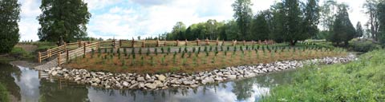
Manitoulin Streams restoration sites on the Mindemoya River
(Photo: MaryEllen Shain)
Every year, salmon and trout journey from Lake Huron to their birthplace in the Mindemoya River on Manitoulin Island, but something fishy has been going on to prevent them from completing their journey.
The mouth of the Mindemoya is a critical entrance point for salmon-spawning journeys but due to wave action from the lake, the mouth becomes blocked with sand every year. In a healthy riverine environment, the river would have enough velocity to carve a channel through the sandbar, creating access for the fish to travel upstream to their spawning beds. Due to upstream erosion, the river has widened and slowed, meaning that it doesn’t have enough force to cut through the sand, and the fish often die trying to cross the shallow water barrier on their way upstream to prime spawning habitat. In the long term, this results in declining fish populations and an unhealthy watershed..
Funded through the 2012 Walmart–Evergreen Green Grants program, the Manitoulin Streams Improvement Association works to establish and improve healthy river ecosystems that contribute to the ecological, social and economic health of the Manitoulin Island region. Their Riparian Zone Enhancement for the Mouth of the Mindemoya River project was created to address the issue of upstream bank erosion that leads to the widening and slowing of the river’s flow, so that it could regain the strength it needs to carve an opening in the sandbar at the mouth.
Through their Green Grant, Manitoulin Streams is working to plant a diverse range of native trees, shrub and other plant species along the banks of the river, resulting in increased soil stability and shade, reduced erosion, improved fish and wildlife habitat and cooler stream temperatures. They are also building fencing and watering pads to restrict livestock from entering the river (a major cause of erosion and turbidity), and rebuilding in-stream fish habitat through the installation of weirs, snags, boulders and LUNKERs (Little Underwater Neighbourhood Keepers Encompassing Rheotactic Salmonids). This is a long-term project that will include ongoing monitoring and restoration work to ensure continued success.
Manitoulin Streams also works to foster stewardship by engaging the local community in planting events, ongoing monitoring and other volunteer activities, as well as educational initiatives such as workshops and resources for individuals on how they can make lifestyle choices that will contribute to a healthy local watershed.
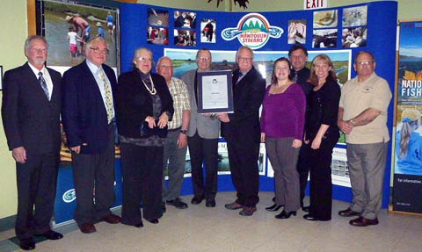
Manitoulin Streams Improvement Association Board of Directors and Staff (L to R) Pax McKenna, Algis Tribinevicius, Therese Trainor, Delmer Fields, Paul Moffatt, Ted Williamson, Sue Meert, Bob Florean, Seija Deschenes and Bill Strain with their National Recreational Fisheries Award
(Photo: Nelson Deschenes)
The dedication of Manitoulin Streams volunteers was recently recognized by Fisheries and Oceans Canada’s 2012 National Recreational Fisheries Award. Created in 1989, the award recognizes “outstanding contributions by individuals and organizations in areas such as recreational community leadership, restoring and enhancing fisheries and fish habitat or promoting conservation and sustainable recreational fishing.” At the ceremony, Ed DeBruyn, Regional Director with Fisheries and Oceans Canada, presented the award to Manitoulin Streams for its leading-edge work in stream rehabilitation. “These dedicated volunteers are making an important contribution to recreational fishing around Manitoulin Island and Lake Huron, and are helping to keep this tradition alive for future generations,” he said.
Evergreen would like to congratulate Manitoulin Streams and its volunteers on this important recognition of their hard work and dedication to the restoration of the Mindemoya River and its fish-spawning habitat for generations to come!

